To monitor your ECS cluster using CloudWatch, we can use CloudWatch Container Insights. This will collect metrics and logs from our ECS cluster.

Here are some CloudWatch metrics that you can use to monitor your ECS cluster:

* CPUUtilization
* MemoryUtilization
* NetworkIn
* NetworkOut
* RunningCount
* PendingCount
* StoppedCount
* DesiredCount

But we need to get alert when service goes down and what is the reason of its down so we need to find out common scenarios when the service goes down

ECS tasks might stop due to a variety of reasons. The most common reasons are:

* Essential container exited
* Failed Elastic Load Balancing (ELB) health checks
* Failed container health checks
* Unhealthy container instance
* Underlying infrastructure maintenance
* Service scaling event triggered
* **ResourceInitializationError**
* **CannotPullContainerError**
* Task stopped by user

Understanding the correlation between a stopped task and stopped reason can help reduce the effort needed to troubleshoot.

**Amazon Elastic Container Service to set up email notifications for stopped tasks.**

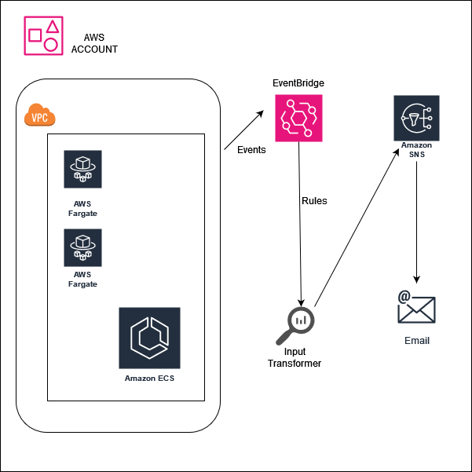

## Prerequisites

1. In this demo, we will be utilizing the ECS Fargate Cluster. Please ensure that you have an active ECS Fargate Cluster running.

2. Additionally, you will require a task definition and an ECS service. Make sure your task is up.

## Deployment Of Alerting Mechanism:

1. In the AWS Management Console, search for “SNS” in the services search bar and click on “Simple Notification Service” when it appears.

2. Click the “Topics” section in the left navigation pane in the SNS console.

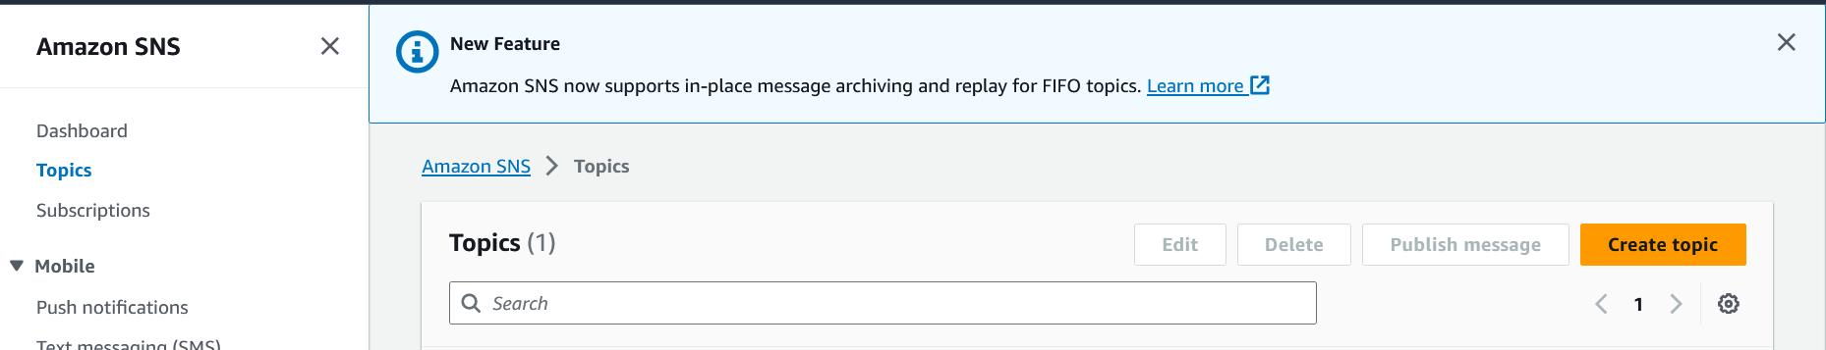

3. Provide the name of your topic in the “Name” field. You can choose a display name that helps you identify the purpose of the topic.

For type, choose standard

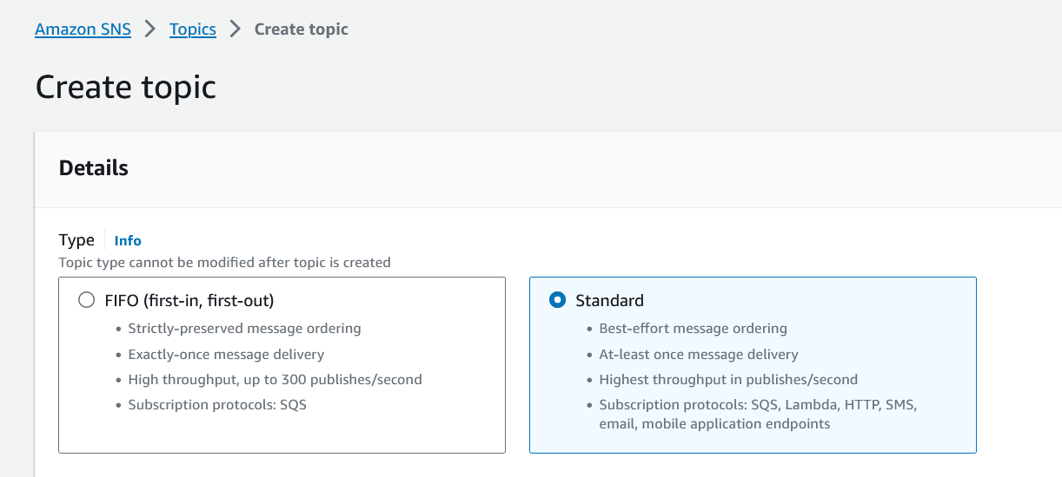

* Name: (choose name. e.g. TaskStoppedAlert)

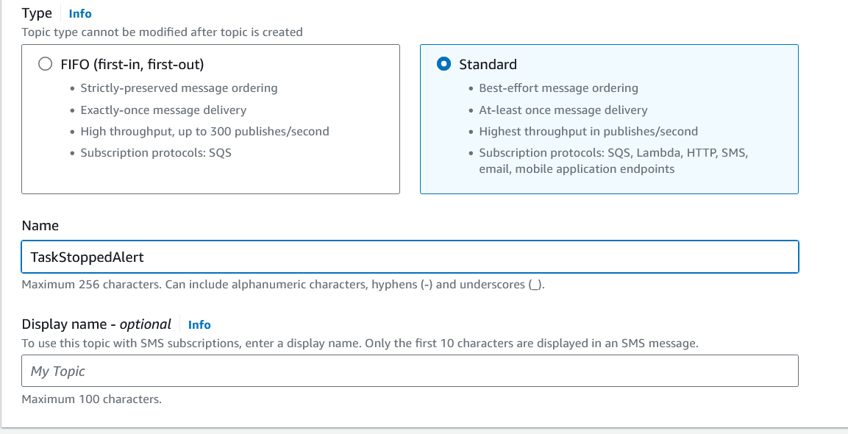

4. Click on the “Create topic” button to create the SNS topic.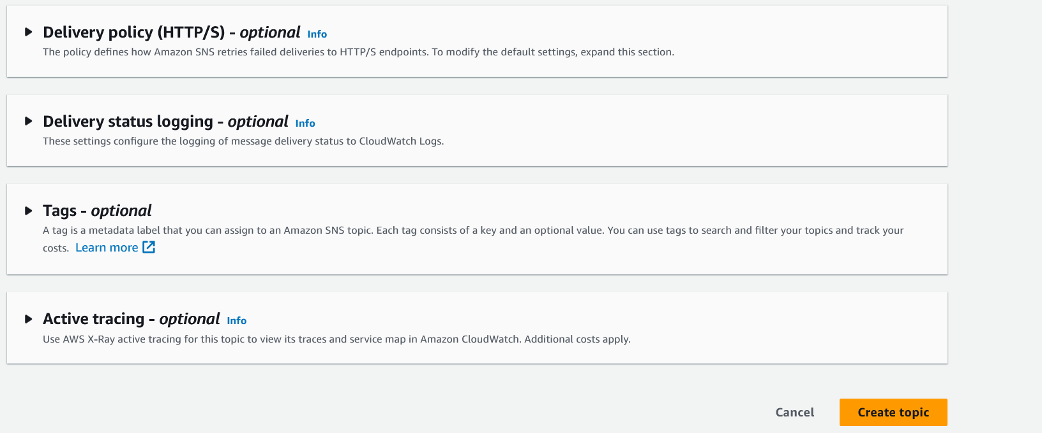

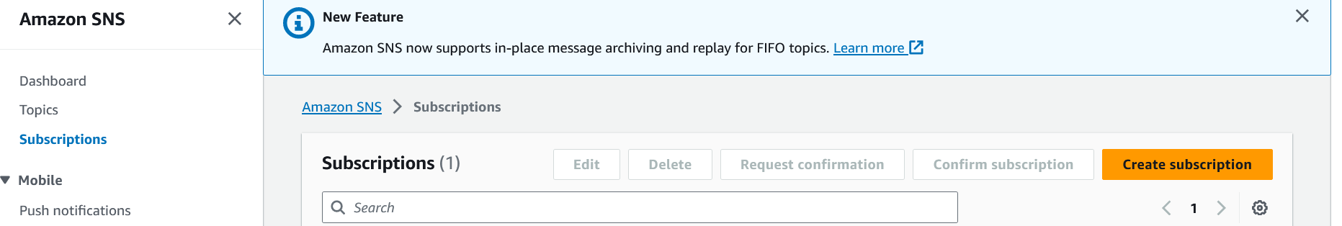

5. Select the topic by clicking on its name. In the topic, details view, click on the “Create subscription” button. Choose the protocol as “Email” from the dropdown menu. Enter the email address where you want to receive the alerts in the “Endpoint” field.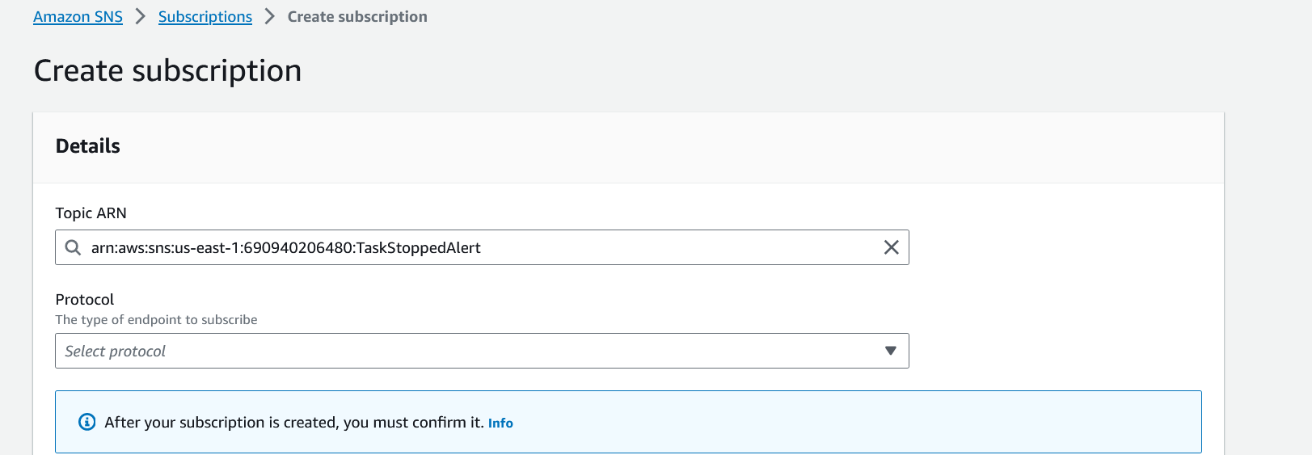

* For protocol, select email

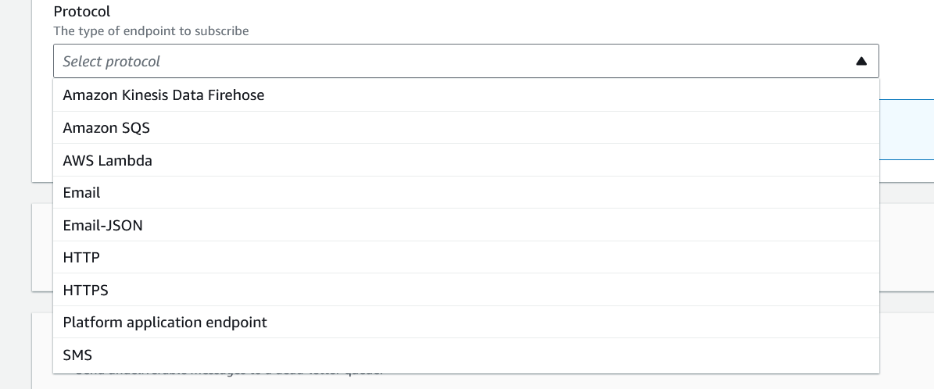

* For endpoint, enter a valid email address

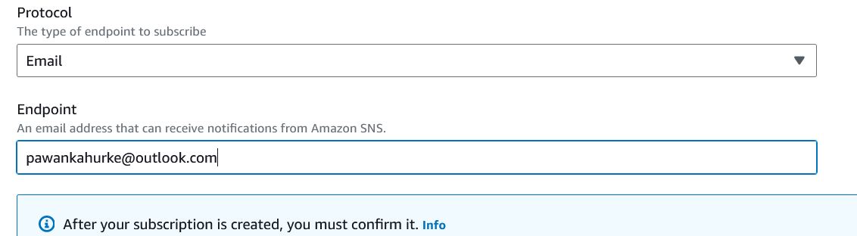

* Click create subscription
* 6. Check the inbox of the subscribed email address for a confirmation message from AWS SNS. Click & subscribe to the notifications.
* 7. Once confirmed, the subscription status will change to “Confirmed” in the SNS console.

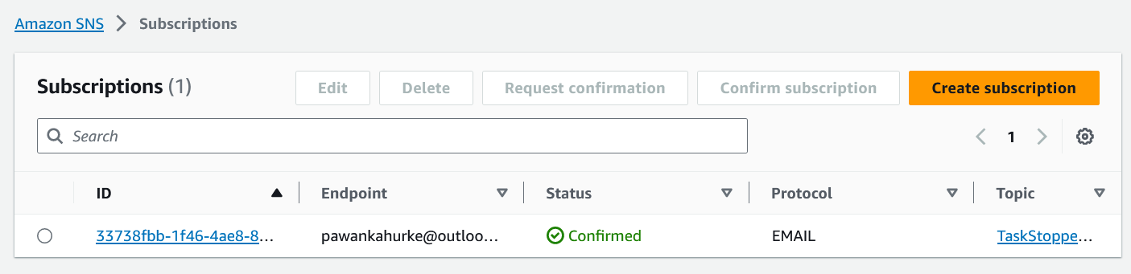

8. Create an Amazon EventBridge rule to trigger the SNS Topic when the state changes to stopped on an ECS Task

* Navigate to Amazon EventBridge in the AWS console

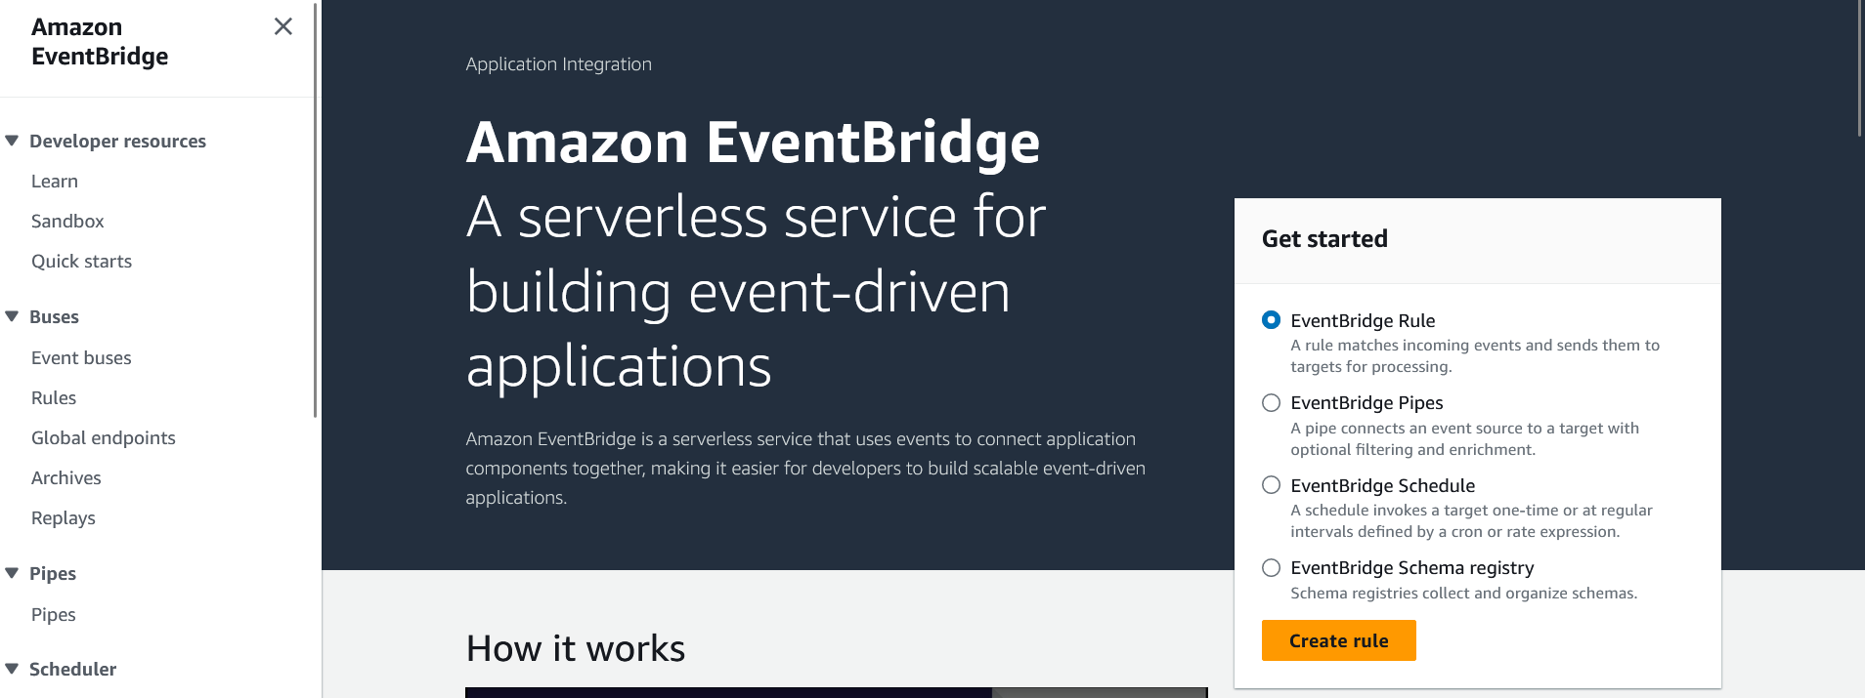

9. In the navigation pane, click on “Create rule”. Provide a name and an optional description for your rule. Click on “Next” to proceed with the configuration of your rule.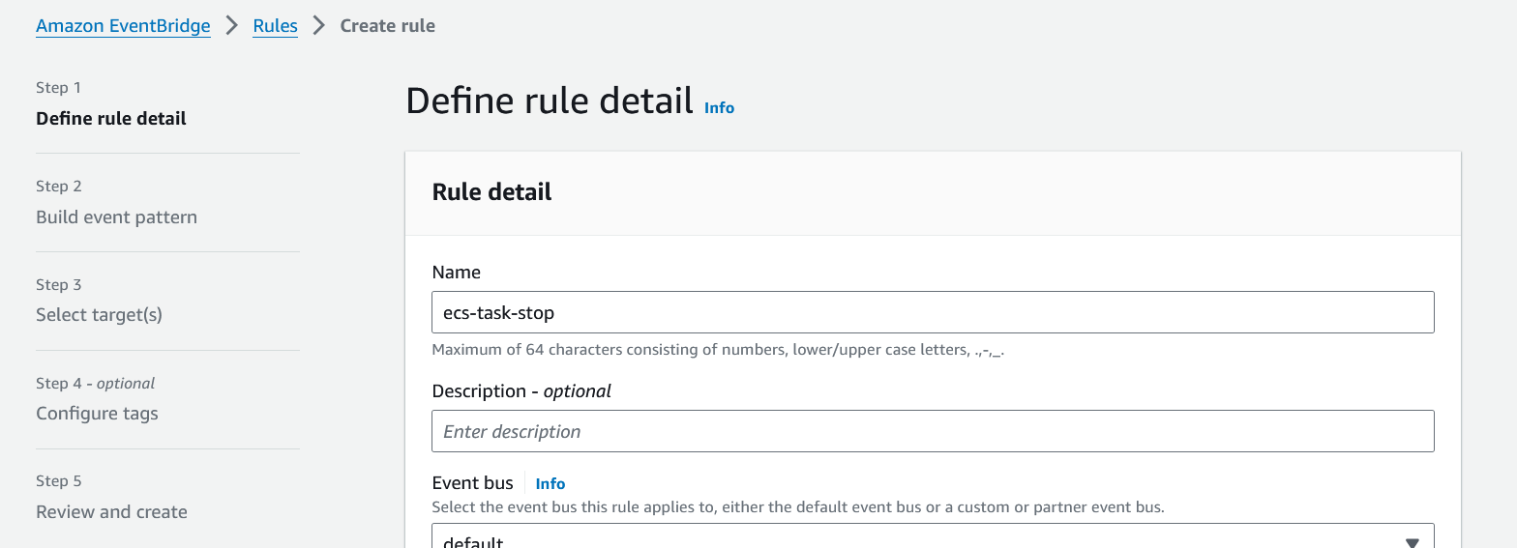

* For rule type, select rule with an event pattern and click next

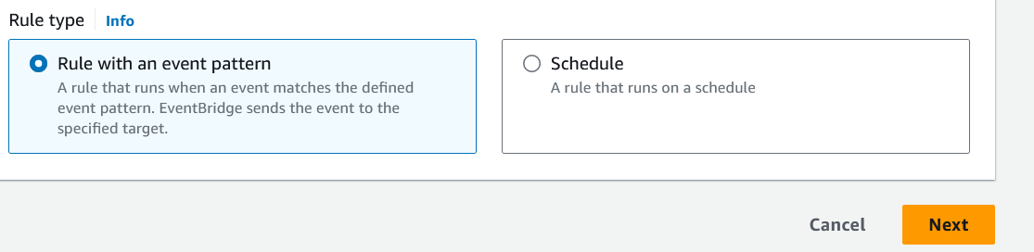

* For event source, choose AWS events or EventBridge partner events

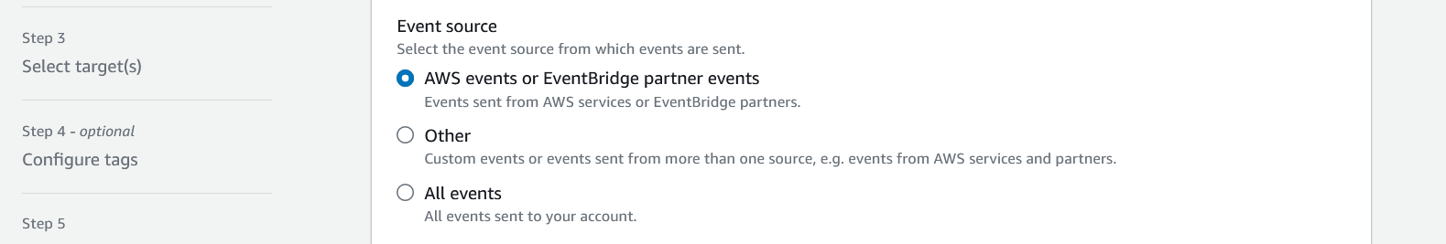

10. Under the creation method, select “Custom event pattern” (JSON EDITOR).

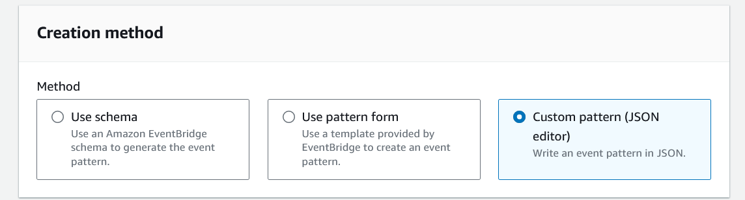

11. Since, By default, all three states(Running, stopped & Pending) will be tracked by the Cloudwatch rule but we only want stopped tasks alerts only. Enter the following pattern in the custom event pattern tab. Click on next.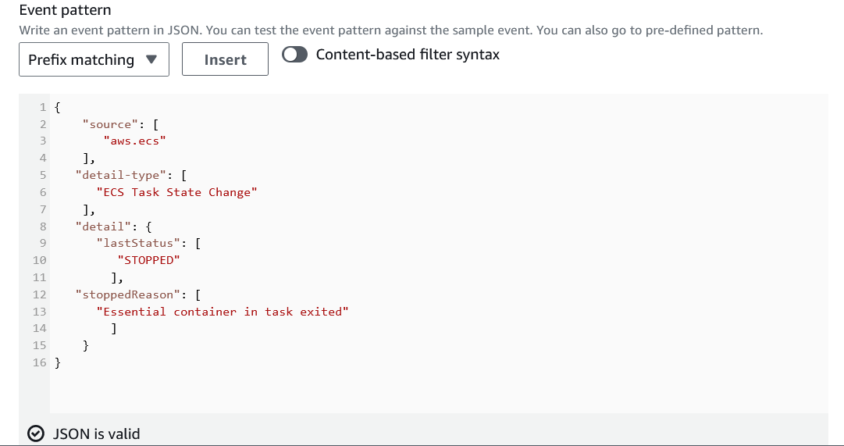

Here in stoppedReason we need to add all the task failed scenarios

{

"source": ["aws.ecs"],

"detail-type": ["ECS Task State Change"],

"detail": {

"lastStatus": ["STOPPED"],

"stoppedReason": ["Essential container in task exited", "Task stopped by user", "CannotPullContainerError", "Failed Elastic Load Balancing (ELB) health checks", "Failed container health checks", "Unhealthy container instance", "Underlying infrastructure maintenance", "Service scaling event triggered", "ResourceInitializationError"]

}

}

12. After configuring the custom event pattern, click on “Next” to proceed. Then, select the SNS Target for the alert. Choose the SNS Topic that you created in Step 4 as the target for the alert.

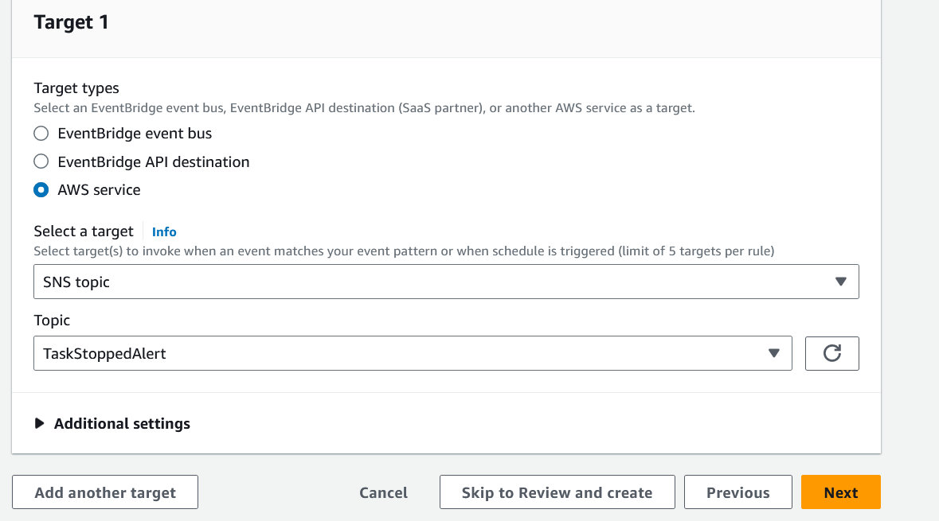

13. After selecting the SNS Target, click on “Additional settings”. This section will utilize the CloudWatch input transformer to transform the event and extract the required values in the desired format.

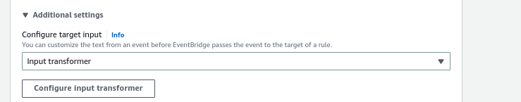

14. Click on “Configure input transformer” under the “Additional settings” section.In the “Target input transformer” field, enter the following input path:

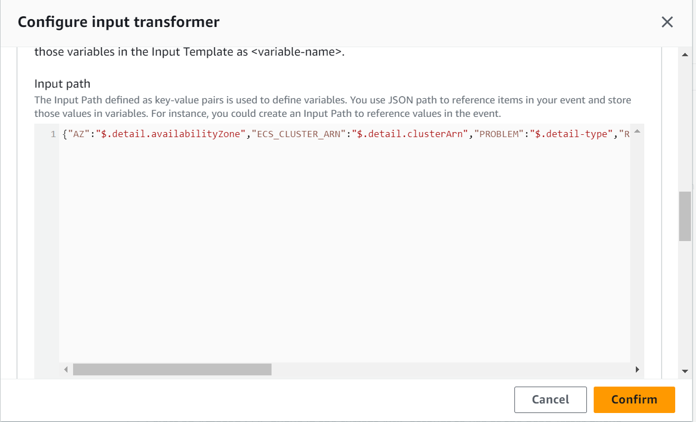

{  
 "TASK_ARN": "$.detail.taskArn",  
 "PROBLEM": "$.detail-type",  
 "STOP_CODE": "$.detail.stopCode",  
 "STOPPED_REASON": "$.detail.stoppedReason",  
 "STOPPED_TIME": "$.detail.stoppedAt",  
 "AZ": "$.detail.availabilityZone",  
 "SERVICE": "$.detail.group",  
 "ECS_CLUSTER_ARN": "$.detail.clusterArn",  
 "REGION": "$.region"  
}

15. Under the Template section, please enter the following content:

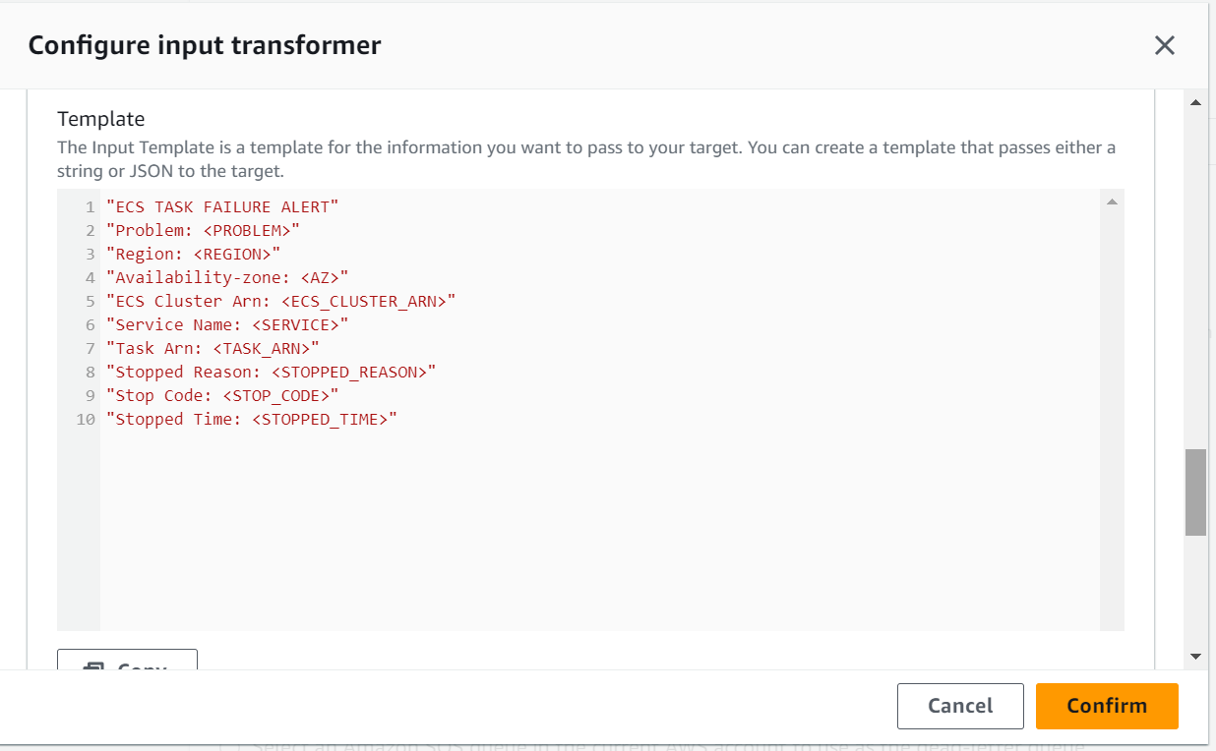

"ECS TASK FAILURE ALERT"  
"Problem: <PROBLEM>"  
"Region: <REGION>"  
"Availability-zone: <AZ>"  
"ECS Cluster Arn: <ECS_CLUSTER_ARN>"  
"Service Name: <SERVICE>"  
"Task Arn: <TASK_ARN>"  
"Stopped Reason: <STOPPED_REASON>"  
"Stop Code: <STOP_CODE>"  
"Stopped Time: <STOPPED_TIME>"

16. This template defines the format of the alert message that will be sent to the SNS topic. The placeholders enclosed in angle brackets (“<>” symbols) will be replaced with the actual values extracted from the event payload. Once you have entered this template content, click on “Next” to proceed.

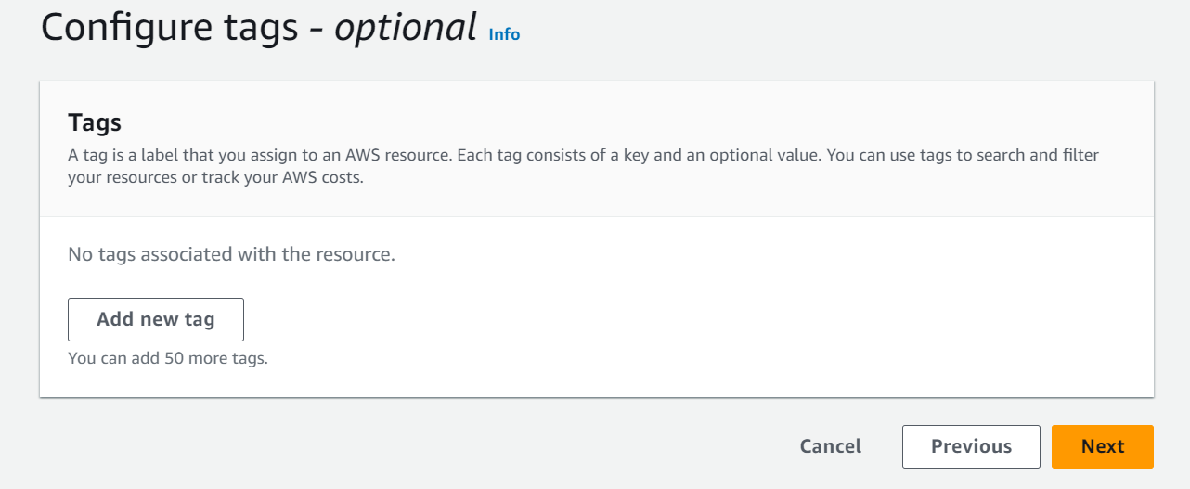

17. Verify everything and click on Create the rule.

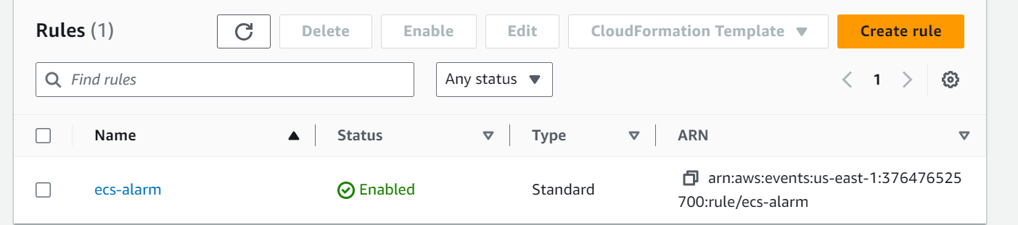

Now, whenever an ECS Fargate task fails, you will receive a notification via email, as shown in the picture below.

